Bugs to be logged in QA Practice Page

Bug ID | Title | Expected Value | Actual Value | Evidence
001 | Spelling mistake in label – Phone number. Also capitalisation should be uniform | Phone Number | Phone nunber | 
002 | Last Name is assumed mandatory | Last Name has ‘*’ marked which implies it should be mandatory | With empty value, form could be submitted successfully
003 | Phone number field accepts alphanumeric | Suggestion label says it should be at least 10 digits | It accepts letters also (although appends NaN in summary at the bottom | 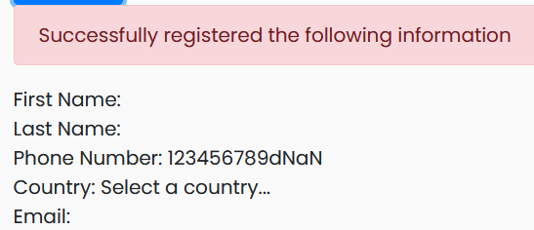
004 | Phone number is not saved correctly | When a valid phone number is provided, last digit is changed | Entered 12345678955. It is shown as 12345678956 | 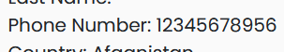
005 | No validation in email address format | It should validate if proper format - <user>@<host/subdomain>.<cn>* | Even putting ‘ABC’ is accepted | 
006 | Email is mandatory, still empty values are accepted | As email field has ‘*’, empty value should lead to error | Empty value accepted | 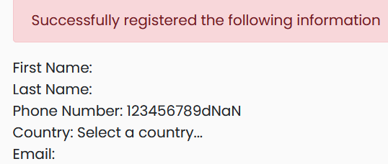
007 | Check box for T&C is not enabled | It is visible but state is disabled | It should be enabled and clicking on it should toggle | 
008 | Check box for T&C is not marked mandatory | It is a practice to mark T&C mandatory, and skipping it is a risk to business. | Even without interacting with it, the form is successfully registered.
009 | Label for password length – uses Psw instead of clear instruction | It says –  Psw length validation | Text should be Password length validation
010 | Duplicate values in registration | With same values input, clicking on Register, allows resubmission | Duplicate registration should not be allowed.
011 | Validation proceeds in steps | If there are multiple missing fields the validation reports only one error at a time.  E.g. Phone num and Password do not meet requirements. Still only one error is shown | Could be design issue, but if multiple errors present, should be shown.
012 | Home button is broken | Clicking on Contact > Home loads random pages instead of going to the previous Bugs Form page | Link for Home should contain correct URL
013 | Reload issue | On refresh, page contents should be fresh and empty | Contents are not cleared when the page is reloaded
0114 | Password visibility | Password should be masked or obfuscated | Password is shown in plain text | 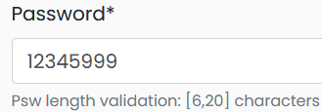
0115 | When country not selected, placeholder is set | When country is not selected from dropdown, then it should show empty | It still shows as- Select a country … | 

